Follow up to the “fun” discoveries during the September workshop about
“How to Share Screen When Hosting a Zoom Meeting”

When I “stop video,” it just shows my name, but other people have a picture or initials. How do I show a picture on zoom instead of my live video?

There are a couple ways to change what people see when your video camera is turned off.

- When you have your own Zoom account, you can add or change your profile picture:

- Sign in to your account at zoom.us  - On the left, select PROFILE  - Under the fake picture, select ADD or CHANGE  - Use the UPLOAD button to direct Zoom to your pictures.  - Click SAVE when you are ready. | 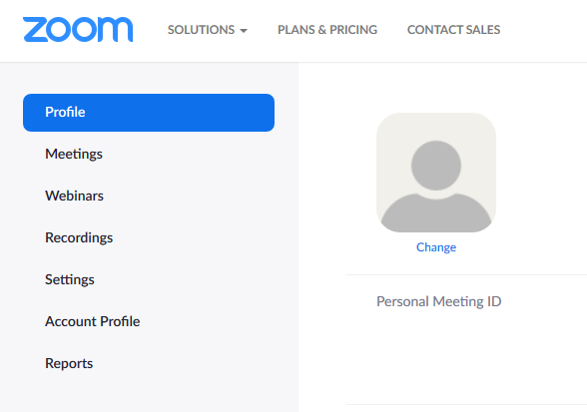

Troubleshooting – sometimes a Zoom will give a message stating that the photo is too large. The photo might have an option to resize to profile size, or you might have to use “crop” to make it smaller.
Note: If the Host enabled the “Hide participant profile pictures in a meeting” option in their settings, your profile will not show.
Note: You need to have pictures on the device you are using when initially setting up your profile image.

- If you are in a Zoom meeting and would like to change your profile picture:
- You can right-click on your video and tap EDIT PROFILE PICTURE.
- Choose the picture from your computer, adjust borders, and save.
- Turn off your video by tapping STOP VIDEO.

Troubleshooting – If this choice is not available,
The person hosting the meeting might need to update and check their settings to make sure “Hide participant profile pictures in a meeting” is turned off;
If you have your own account, you might need to update and check your settings to make sure “Hide participant profile pictures in a meeting” is turned off.
Note: You need to have pictures on the device you are using when initially setting up your profile image.

Another Fun Zoom Feature: Video Filters
Zoom has two kinds of video filters. The original filters are ways to change your appearance. Recently added are funny filter graphics that you can add to your video!

1. Original Video Filters
Inside a Zoom meeting, use the arrow next to the stop/start video.
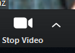

Select Video Settings, and then look for the MY VIDEO choices:
- Mirror my video
- Touch up my appearance
- Adjust for low light

2. New August 2020 – Funny Filters
Inside a Zoom meeting, use the arrow next to the stop/start video.

Select: Video Filters
- Click on the filter(s) you want to try, and return to the Zoom room.
- When you are finished with Video Filters, go back to Video Filters and click on the black square that says NONE.
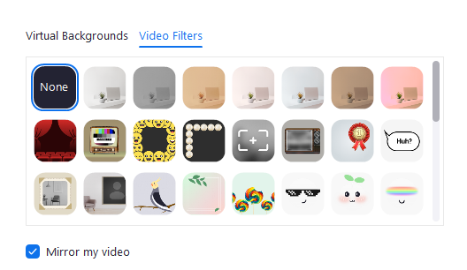

Troubleshooting – During each Zoom meeting, some people had these pictures to try, but others did not.

If you do not have the funny filter graphics, and if you have your own Zoom account, you need to make sure that
- Video Filters is turned on in Settings, and
- That your Zoom Account has been updated recently

Check Settings  - Open your account on zoom.us  - Look to the left side of the screen and select SETTINGS  - Scroll down to VIDEO FILTERS, and see if the button is blue for “on” or gray for “ off  - If it is off, click the button to turn the feature on | 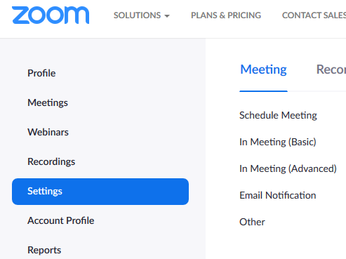
Getting Zoom Updates | - Go to https://zoom.us/download to the Zoom Download Center  - Download the latest version of zoom  - Depending on your device, you might have to open the installer  - When it is done, it will tell you to sign in to your account

