Follow up Notes from the October 29, 2019, “Ask a Clinician” Virtual PD Workshop

Thank you to the Finger Lakes Community Health, Behavioral Health Team, for discussing the scenarios sent ahead of time and for making time to discuss scenarios/questions from participants during the workshop.

These scenarios included situations that can trigger behavioral health issues, such as students dealing with the realization that their immigration status can hinder their plans to afford going to college; a death in the family; parents in deportation; being in a new country and missing their old way of life; bullying; substance abuse; divorce; and eating disorders.

Summary by TASC
The first advice in each situation was to create a safe space in the tutoring session. Building a relationship with the student and family, so it is comfortable for you to check in with the student’s day is going and the student can speak about what is on their mind.
- From the perspective of trauma-informed instruction, students need someone to listen to them before they are able to focus on instruction.
- Giving students time to talk.
- Bottom line: Listen.

Red Flag
It is common for someone to need to talk about a concern for two to three sessions and then to be over it. However, when the need to talk about it continues on, it can be a sign that the student needs help coping

Migrant Educators should let their Directors know when have concerns about a student, to help decide next steps. Depending on the individual situation, next steps might include (these are not listed in any particular order):
- Referral to
  - school counselor
  - primary health care provider
  - counseling
  - local, free, legal advocate
- Report when it is a mandated reporter situation
- Conversation with student and/or parent: “It seems like this is something you need to talk about with someone, is it okay if I see if I can link you with someone to talk with?”
- In tutoring sessions, work on goal setting with students, to help them regain some control in part of their life.
Preparation
METS and Migrant Educators can take some steps to be prepared to deal with issues.
- Discuss protocols within the METS, such as calling the Director when issues arise to discuss next steps.
- Continue building relationships
  - with the student and family
  - with the school
  - with community agencies, learning their referral processes
- Continue to give students space to talk
- Continue to make time to listen
- New Fall 2019: Students in New York State now have the NYS DREAM Act to support undocumented students with some of the college cost

Agencies and website resources provided during the workshop and captured by TASC
Health Homes provides care management to help client negotiate providers and appointments. Client needs to qualify for Medicaid. - https://www.medicaid.gov/medicaid/ltss/health-homes/index.html
Also google for upstate NY:
- Hhuny.org
- chhuny.org (children health homes)

HRH Care Community Health – provide migrant-specific health care in the Mid-Hudson and Long Island area - https://www.hrhcare.org

Substance Abuse – NYS Office of Alcoholism and Substance Abuse Services (OASAS) –
https://www.oasas.ny.gov/

National Alliance on Mental Health – https://nami.org/
- Free trainings for inservice; resources, handouts
- Groups for students and families

Programs to connect students to adults
- Big Brother/Sister
- YMCA
- Youth Advocacy Program (YAP)
Eating Disorders – NYS Office of Mental Health - https://www.omh.ny.gov/
- Best to call the customer service number at the bottom of the home page

About Finger Lakes Community Health (FLCH)

- Federally Qualified Health Center  - 7 health center sites  - Medical, Dental, and Behavioral Health  - Community Health Workers, Patient Navigators, Insurance Enrollers, HHUNY Care Managers | 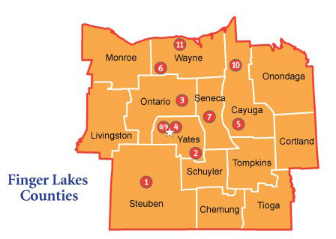

Note: In addition to these counties, FLCH will assist METS with finding healthcare and negotiating payment assistance for students and families in counties not served by the Hudson Valley program, HRH Care Community Health.

