ELIGIBILITY REVERSAL FORM
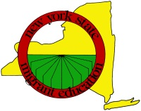

COE#: ________________________ County: __________________ School District: _____________________

Parent/Guardian’s Name: ____________________________________________

Address: _________________________________________________________

_________________________________________________________

Children’s Names:_____________________ Age:_____ _______________________ Age:_____

______________________ Age:_____ _______________________ Age:_____

______________________ Age:_____ _______________________ Age:_____

Reason for Eligibility Reversal: (Please explain in detail.)

__________________________________________________________________________________________

__________________________________________________________________________________________

__________________________________________________________________________________________

__________________________________________________________________________________________

Recruiter Signature: _____________________________________ Date: __________________

ID/R Director Signature: __________________________________ Date: __________________

NEW YORK STATE MIGRANT IDENTIFICATION/RECRUITMENT OFFICE

